Installation, setup, and troubleshooting guide – Pinball Additive Color

Prep:
- Confirm contents of wagon:
  - Cord bag
  - Printer
  - Extra paper and ink
  - Camera and stand
  - Computer
  - Controller
  - Tablecloth and non-slip mat
  - Extension cord
- Screen

If nothing has changed since last run

If files (Unity and/or TouchDesigner) have been updated

If a hotspot or confirmed available wifi at install location is available, do the next step on site, otherwise plug in demo computer and into a monitor, login is #5 below
- Pull from Github
  - Open Github Desktop – Fetch Origin, then Pull Changes (button circled in red below)
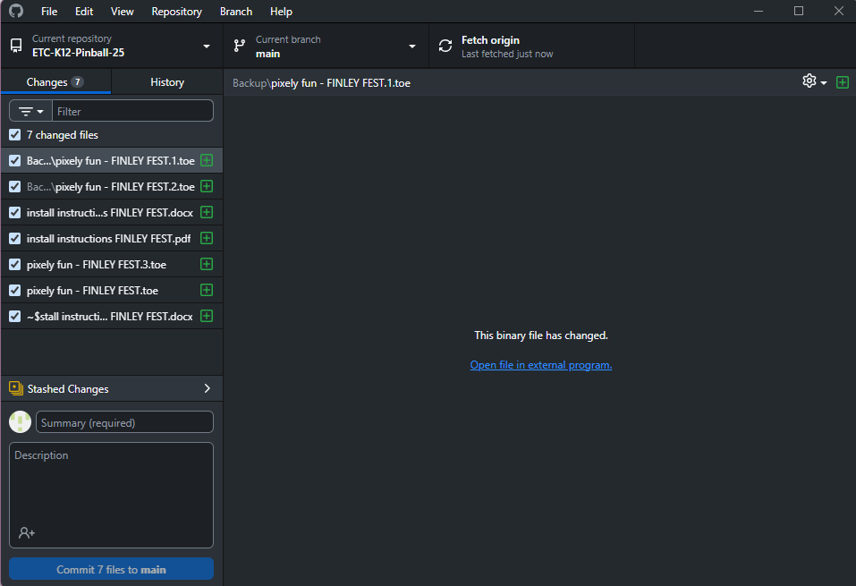
On Site Install:
- Plug everything in (use the power strip)
  - Screen
  - Computer
  - Printer (plug in power and USB, insert tray)
  - Mouse
  - Keyboard
  - Camera (likely will put on tripod, set up about 3’ high (? *AV confirm) in the center of the screen
  - (*AV insert reference pic)
- Log in
  - User: demo
  - Password: etcdemo123
- For ease of setup, right click on taskbar (bottom bar with icons) head to taskbar settings. Under taskbar behavior uncheck automatically hide taskbar.
- Decide whether or not you will be using sound. If so, select proper source and set the volume to on, adjust later.
- Be patient, several applications open on start
- Connect to wifi and pull from Github (see #3, if not already done)
- Turn off wifi, (accidentally connecting can mess up NDI connection)
- Open NVIDIA Broadcast window (opens automatically)
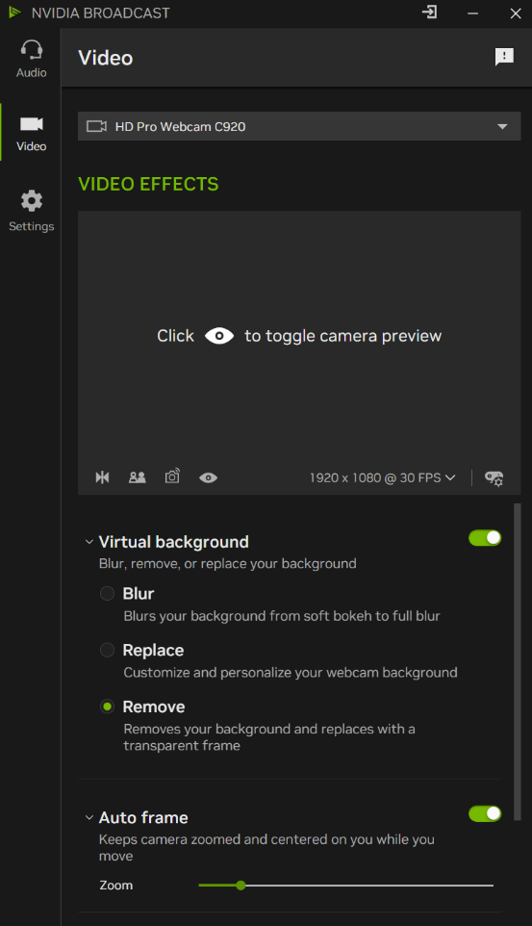
- Open unity hub and open Unity_Project (*AV add file path for if it gets removed)
- The TouchDesigner (TD) file will open automatically
  - If closed find it (*AV nav)
- Open the Unity Editor, navigate to Photo Camera Manager (below right), in inspector panel, switch to ETC-PINBALL-02 (TouchDesigner) (*AV replace pic)
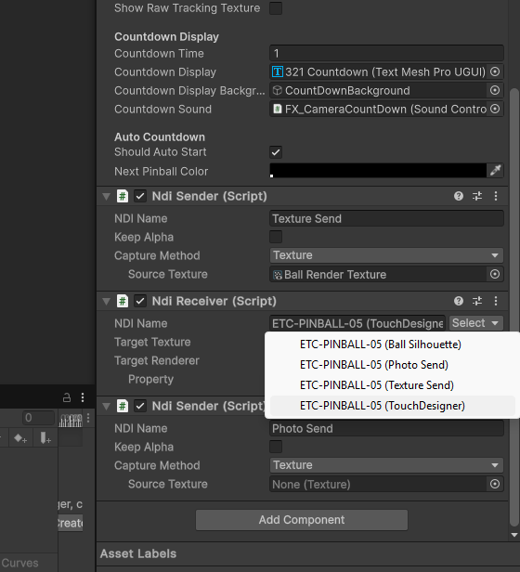
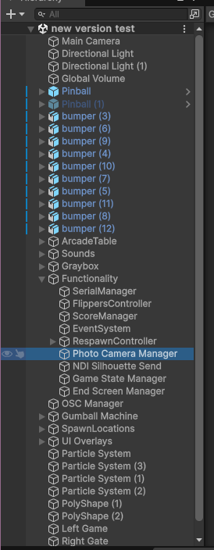
- Play scene (ctrl + p), go through tutorial, launch a few balls and switch to TD
- Nav to TD window
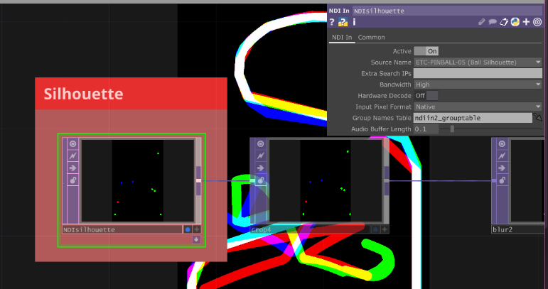
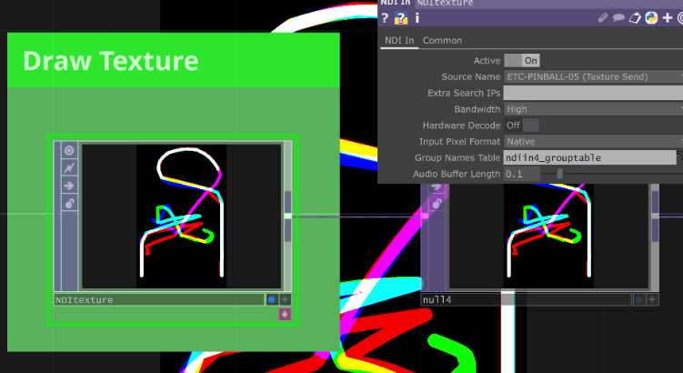
- Put all windows to as follows, (*AV update pics 02 instead of 05)
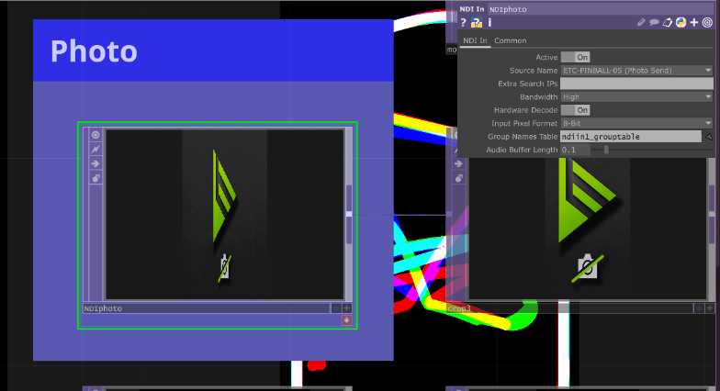

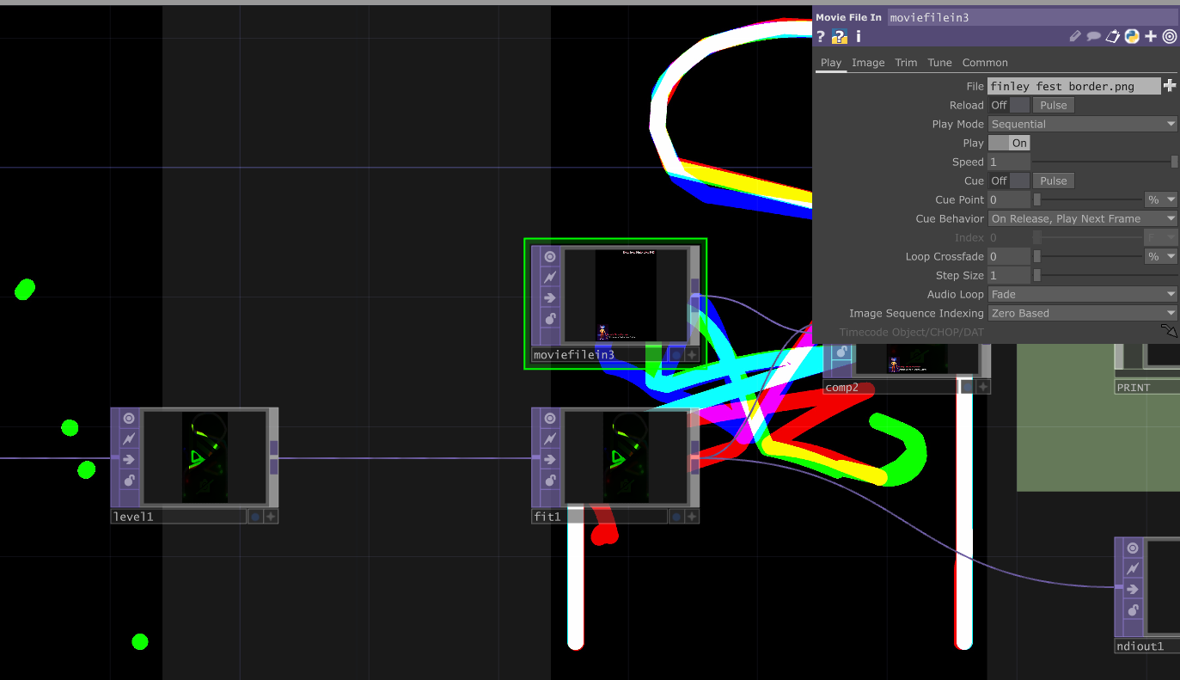
- Instructions for alternate border? (*AV update with colored border)
  - If not, double click file name and open border
- Final adjustments:
  - Ensure play mode tint is black; it should look like this:
  - If not, stop playing (ctrl+p), navigate to Edit > Preferences> colors, scroll to play mode tint and select black (insert pic)
  - Full screen game mode
  - Adjust volume if using sound
  - Hide taskbar (see #6, check box)

Troubleshooting:
- First, go back through the list and double check:
  - Is everything plugged in?
  - Are all NDI points correctly selected?
  - Is wifi turned off?
- If ball tracking isn’t live on the gameboard:
- If it is not printing:
- If controller isn’t registering

